Land Registry System using Blockchain

Submitted in partial fulfilment of the requirements for the award of the degree of

Bachelor of Engineering
(Computer Engineering)
by
Mr. Prateek Tiwari
Mr. Nyani Shinde
Mr. Saurabh Dalavi

Under the guidance of Prof. Shilpa Doke

Department of Computer Engineering Suman Educational Trust’s
Dilkap Research Institute of Engineering & Management Studies Mamdapur, Post: Neral, Taluka: Karjat, Dist: Raigad – 401101

University of Mumbai Academic Year 2025-26
A
Major Project Report On

Land Registry System using Blockchain

Submitted in Partial Fulfillment of the Requirement of the University of Mumbai for the Degree of

Bachelor of Engineering (Computer Engineering) By
Saurabh Dalavi 22
Nyani Shinde 75
Prateek Tiwari 77

Under the Guidance of

Prof. Shilpa Doke



Department of Computer Engineering Suman Educational Trust’s
Dilkap Research Institute of Engineering & Management Studies, Mamdapur, Post:Neral, Taluka:Karjat, Dist:Raigad-410101

University of Mumbai Academic Year 2025-26

CERTIFICATE

This is to certify that the project entitled “Land Registry System using Blockchain” is a bonafide work of Mr. Prateek Tiwari 77, Mr. Saurabh Dalavi 22, and Ms.Nyani Shinde 75 submitted to the University of Mumbai in partial fulfilment of the requirement for the award of the degree of "Bachelor of Engineering" in "Computer Engineering”.

……………………………………

Project Guide (Prof. Swati Shelar)

…………………………………… ……………………………………

HOD Principal
(Prof. Archana Mate) (Dr. Shashank Divgi)

Place: Neral

Date: ……………………….

PROJECT REPORT APPROVAL FOR B. E.

This project report entitled “Land Registry System using Blockchain” by Mr. Prateek Tiwari 77, Mr. Saurabh Dalavi 22, and and Ms.Nyani Shinde 75 is approved for the degree of “Bachelor of Engineering” in “Computer Engineering”.

Examiners

1…………………………………

(Internal Examiner Name & Sign)

2………………………………… (External Examiner Name & Sign)

Place: Neral

Date: ……………………….

DECLARATION

We declare that this written submission represents our ideas in our own words and where others’ ideas or words have been included, we have adequately cited and referenced the original sources. We also declare that we have adhered to all principles of academic honesty and integrity and have not misrepresented or fabricated or falsified any idea/data/fact/source in our submission. We understand that any violation of the above will be cause for disciplinary action by the Institute and can also evoke penal action from the sources which have thus not been properly cited or from whom proper permission has not been taken when needed.

Mr. Prateek Tiwari (77) ……………………………...

Mr. Saurabh Dalavi (22) ……………………………...

Ms. Nyani Shinde (75) ……………………………...

Date: ……………………….

ACKNOWLEDGEMENT

We are also obligated to acknowledge the support and assistance provided by our colleagues and other staff members for their valuable feedback and guidance throughout the project. We would like to express our sincere appreciation to our families and friends for their encouragement and support during the course of the project. Lastly, we would like to thank the Almighty for His everlasting blessings in our lives. Overall, this project would not have been possible without the support and guidance of all those involved. We are truly grateful for this opportunity and look forward to applying the knowledge and skills we have gained in our future endeavours.

It is heartening to read about the acknowledgement and appreciation expressed towards the project coordinator, Prof. Shilpa Doke, along with the parents and mentors who have provided their unwavering support. Recognition and gratitude go a long way in fostering a culture of collaboration and teamwork, while also inspiring individuals to strive for excellence. As a student, I believe that such expressions of appreciation are key to building strong relationships and driving positive outcomes.

Table of Contents

i | Abstract | 4
ii | Acknowledgement | 5
iii | List of Abbreviations | 6
iv | List of Figures | 7

Chapter 1 | Introduction | 8
Chapter 2 | Literature Survey | 13
Chapter 3 | Problem Definition | 17
Chapter 4 | Proposed System | 19
Chapter 5 | System Requirement | 23
Chapter 6 | System design | 24
Chapter 7 | Outputs | 30
Chapter 8 | Conclusion | 32
 | References | 34

ABSTRACT

The Land Registry System using Blockchain aims to revolutionize the traditional land registration process by introducing a secure, transparent, and decentralized platform. Conventional land records in India are prone to inefficiencies, fraud, and manipulation due to their centralized and paper-based nature. This project leverages blockchain technology to ensure immutability, transparency, and traceability of property transactions. Using smart contracts written in Solidity, ownership transfers are automated upon verification, eliminating intermediaries and delays. The system integrates a user-friendly web interface with blockchain and IPFS for document storage, allowing citizens, government officials, and registrars to access verified records in real time. By combining decentralization and automation, the proposed system enhances trust, reduces corruption, and provides a scalable solution for secure digital land manage

List of abbreviation:

Abbreviation | Full form
API | Application Programming Interface
DLRMP | Digital Land Record Management Program
GUI | Graphical User Interface
IPFS | InterPlanetary File System
dApp | Decentralized Application
ETH | Ether (Cryptocurrency used in Ethereum Network)
IDE | Integrated Development Environment
DB | Database
AWS | Amazon Web Services
CI/CD | Continuous Integration / Continuous Deployment
HTML | HyperText Markup Language
CSS | Cascading Style Sheets
JS | JavaScript
VS Code | Visual Studio Code
RBI | Reserve Bank of India
SDE | System Development Environment
ETH | Ethereum (Blockchain Platform)

List of Figures :

No. | Description | Pg No
1 | DECENTRAILIZED BLOCKCHAIN TECHNOLOGY | 9
2 | SMART CONTRACT WORK FLOWCHART | 12
3 | DATA FLOW ACROSS VARIOUS LAND REGIRSTRATION MODULES | 17
4 | METHODOLOGY LAND REGISTRATION VERIFICATION FLOWCHART | 26
5 | DESIGN OF DATA FLOW | 28
6 | DATA FLOW DIAGRAM | 29
7 | BLOCKCHAIN RECORD TRANSACTIONS | 30
8 | BLOCKCHAIN LAND REGISTRY INTERFACE | 31
9 | SUCCESFUL DEPLOYMENT OF CONTRACT | 32

Introduction

  - ​Introduction
The project proposes a blockchain-based system that stores property transactions as blocks in a distributed ledger. This ensures immutability, transparency, and traceability of ownership. The system will also use smart contracts to automate ownership transfers upon verification and provide access control for different users, such as citizens, registrars, and the government.
Traditional land registry systems are deeply rooted in historical, centralized, and paper-based processes. These conventional methods are often plagued by significant vulnerabilities that compromise their integrity and efficiency. Key issues include a lack of transparency, susceptibility to corruption, and the potential for document forgery. The reliance on a centralized authority makes these systems a single point of failure and a prime target for malicious activities. Furthermore, the slow and often cumbersome record-keeping processes can lead to inefficient land record management, resulting in protracted disputes, the duplication of ownership records, and illegal sales. This project seeks to address these fundamental flaws by leveraging the unique capabilities of blockchain technology, a decentralized and immutable ledger system
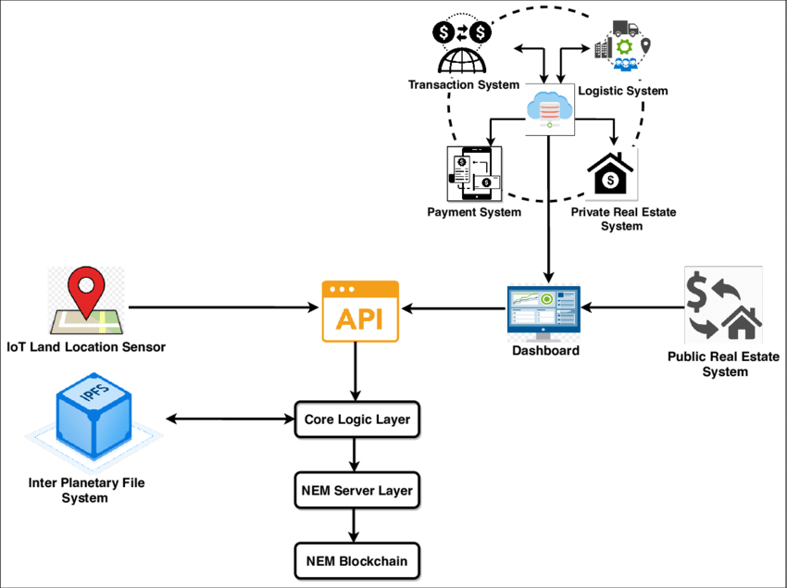
Figure-: 1 DECENTRAILIZED BLOCKCHAIN TECHNOLOGY

Motivation
The main purpose of this project is to develop a secure, transparent, and efficient Land Registry System using blockchain technology that can revolutionize the way land ownership records are maintained, verified, and transferred. The traditional paper-based systems for land registration are often prone to fraud, data tampering, unauthorized alterations, and time-consuming verification processes, which result in disputes and inefficiencies in property management. To overcome these challenges, this project aims to leverage the immutable and decentralized nature of blockchain to create a tamper-proof ledger that ensures trust, authenticity, and transparency among all stakeholders—citizens, property owners, and government authorities. The system will be designed to support faster verification and recording of land ownership transactions by integrating blockchain with a secure, scalable database capable of maintaining distributed ledgers of all land records. Each transaction, such as a new land registration or an ownership transfer, will be cryptographically recorded on the blockchain, ensuring that every entry is verifiable and permanent. The project also focuses on developing a user-friendly graphical interface (GUI) that enables government officials to access and manage the registry efficiently, while allowing citizens to track their land record status in real time with complete transparency. Furthermore, the system will have the capability to accurately verify ownership and property details using the immutable ledger, eliminating the possibility of duplicate or false claims. The proposed Land Registry System will also allow secure recording of new land entries or property transfers directly through the interface, with real-time confirmation messages displayed to users indicating the successful completion of the registration or verification process. Ultimately, this project seeks to establish a digitally reliable, corruption-resistant, and transparent land management system that enhances public trust and operational efficiency while paving the way for the modernization of government record-keeping practices.

Problem Statement & Objectives:
    - Problem Statement :-
Traditional land registry systems in India are primarily paper-based and centralized, making them prone to inefficiencies, fraud, and data manipulation. The lack of transparency and trust in current record-keeping methods often leads to land disputes, ownership duplication, and corruption. Existing digital systems like DLRMP (Digital Land Record Management Program) still rely on centralized databases that are vulnerable to cyberattacks and data loss.
Moreover, manual verification and lengthy approval processes cause unnecessary delays and increase administrative overhead. Therefore, there is a critical need for a secure, transparent, and tamper-proof system that can streamline land registration, verification, and ownership transfer using modern decentralized technologies.

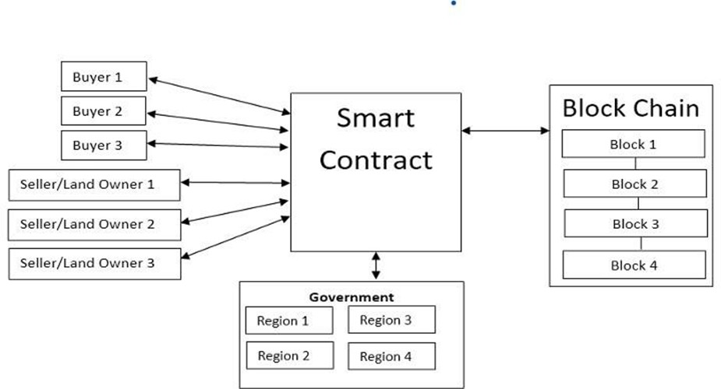

Figure-: 2 Smart Contract Work Flowchart
1.3.2 OBJECTIVES
The main objective of this project is to design and implement a secure, transparent, and decentralized land registry system using blockchain technology. The specific objectives include:
      - To develop a blockchain-based platform that records and verifies land ownership details in an immutable and transparent manner.
      - To automate the process of land registration and ownership transfer using smart contracts to reduce human intervention and errors.
      - To enhance security by eliminating centralized storage and preventing data manipulation, forgery, and corruption.
      - To provide transparency so that all stakeholders—citizens, government officials, and registrars—can verify land records in real time.
      - To integrate a user-friendly web interface that allows easy access for property owners and government authorities.
      - To reduce operational time and cost by minimizing paperwork and automating verification procedures.
      - To ensure scalability so the system can handle a large number of land records across multiple regions.
      - To build trust among users by maintaining a decentralized ledger that provides accuracy, traceability, and accountability.

1.3.3 Organization of Report:

This report is organized as follows:

- Chapter 2 presents the literature survey, including existing systems and identified gaps.
- Chapter 3 describes the proposed system, including its architecture and process design.
- Chapter 4 outlines the experiments conducted and the results obtained.
- Chapter 5 concludes the report and suggests potential future work

Literature Survey

Existing Land Registry System

The existing land registry systems in India and many other countries are predominantly centralized and paper-based, which makes them prone to inefficiencies, errors, and corruption. The process of registering land involves several intermediaries, including brokers, government clerks, and legal officers, which not only increases the overall cost and time but also opens multiple loopholes for fraudulent practices. Records are typically stored in local government offices and maintained manually, making them vulnerable to loss, tampering, or damage due to human error or natural disasters. Although initiatives like the Digital Land Record Management Program (DLRMP) have been introduced to digitize records, the system still relies on centralized databases, meaning a single breach or system failure can compromise the entire record set. In addition, due to a lack of integration between departments, verifying property ownership or transaction history requires multiple approvals, causing significant delays. The absence of transparency and public accessibility further contributes to land ownership disputes and illegal sales. Therefore, despite partial digitalization, the existing system fails to ensure full security, transparency, and traceability—highlighting the urgent need for a blockchain-based decentralized approach that addresses these fundamental shortcomings.
- Centralized Vulnerability: Traditional databases have a "Single Point of Failure." A breach at the central server can lead to massive data loss or unauthorized manipulation of records.

- Public Key Infrastructure (PKI): Most modern systems use PKI to secure communications between users and government portals. While effective for encryption, it does not inherently prevent "inside jobs" or administrative tampering.

- Encrypted Cloud Storage: Some systems use AES-256 encryption to store scanned land deeds. However, the metadata and ownership records remain in a mutable state within the database.

2.2 Limitations of Existing Systems or Research Gap:

Lack of Transparency and Security:
Traditional and partially digitalized land registry systems are centralized, making them vulnerable to manipulation, unauthorized access, and corruption. The absence of tamper-proof mechanisms allows fraudulent activities such as duplication of ownership and illegal sale of property records.

Centralized Data Storage and Single Point of Failure:
Current systems store all land records in centralized government databases. If the database is compromised or corrupted due to technical failure or cyberattacks, all stored data can be lost or altered, leading to disputes and lack of trust among users.

Manual Verification and Inefficiency:
Property registration and ownership transfer still depend heavily on manual processes involving multiple intermediaries. This results in time-consuming verification, redundant paperwork, and delayed updates in ownership records.

Limited Accessibility and Poor Integration:
Citizens, especially in rural areas, face difficulties accessing their land records due to limited digital connectivity and lack of unified platforms. The absence of integration between departments (such as revenue, banking, and municipal systems) further delays the verification and registration process.

Lack of Research on Blockchain Implementation:
Although several studies propose digital land management, few have explored a fully decentralized blockchain-based system with smart contracts for automation and immutability. There is a research gap in implementing a scalable and transparent solution that ensures data integrity and real-time access for all stakeholders.

2.2 Comparison of Cryptographic Protocols
To ensure the integrity of land records, different cryptographic methods are utilized

Protocol | Purpose | Strength | Weakness
SHA-256 | Data Hashing | Provides unique fingerprints for blocks; extremely difficult to reverse. | High computational cost during mining (Proof of Work).
ECDSA | Digital Signatures | Uses Elliptic Curve Cryptography for secure ownership verification and transfer. | Vulnerable to future quantum computing attacks.
Zero-Knowledge Proofs (ZKP) | Privacy | Allows verification of ownership without revealing the owner's identity or transaction price. | High mathematical complexity and setup time.
RSA | Data Encryption | Standard for securing communication channels between nodes. | Slower than ECC/ECDSA for the same security level.

2.3 Major Project Contribution:
- Project Scope

The project focuses on developing a secure, transparent, and decentralized Land Registry System using Blockchain technology to overcome the limitations of traditional land record management. The system will enable digital storage, verification, and transfer of property ownership through

blockchain’s immutable ledger. It covers essential modules such as user registration, property management, access control, smart contract execution, and ownership transfer verification. The scope also extends to integrating a user-friendly web interface and using IPFS for storing property documents, making the system accessible to both government officials and citizens.

Key Contribution

  - Developed a blockchain-based framework that ensures tamper-proof and transparent land record storage.
  - Implemented smart contracts to automate ownership transfer and verification, reducing human intervention and corruption.
  - Designed a decentralized data structure to eliminate single points of failure and enhance system reliability.
  - Integrated a web-based portal for property registration, verification, and record retrieval with real-time tracking.
  - Provided a secure authentication mechanism for different user roles such as buyers, sellers, and government officials.

Implementation Features
  - Blockchain Integration: Property data and ownership transactions are stored in a decentralized blockchain ledger ensuring immutability.
  - Smart Contracts Automation: Automates key processes such as ownership transfer, payment release, and verification once predefined conditions are met.
  - User Management System: Allows role-based access where users (citizens, registrars, and government officials) have different permissions.
  - Geo-Mapping Feature: Uses Google Maps API to visualize and highlight property boundaries using geo-coordinates.

  - Document Storage: Utilizes IPFS (InterPlanetary File System) for secure document storage and retrieval.
  - Web-Based Interface: Built using HTML, CSS, and JavaScript with backend integration via Node.js or Python for seamless access and usability.

Expected Outcome
  - A secure and transparent digital platform for land record management that eliminates data manipulation and fraud.
  - Automated and paperless land registration process, reducing time, cost, and dependency on intermediaries.
  - Real-time access to verified land ownership details for citizens and government authorities.
  - Improved trust and accountability through immutable blockchain records and smart contract verification.
  - A scalable and sustainable model that can be extended to other administrative and real estate applications in the future.
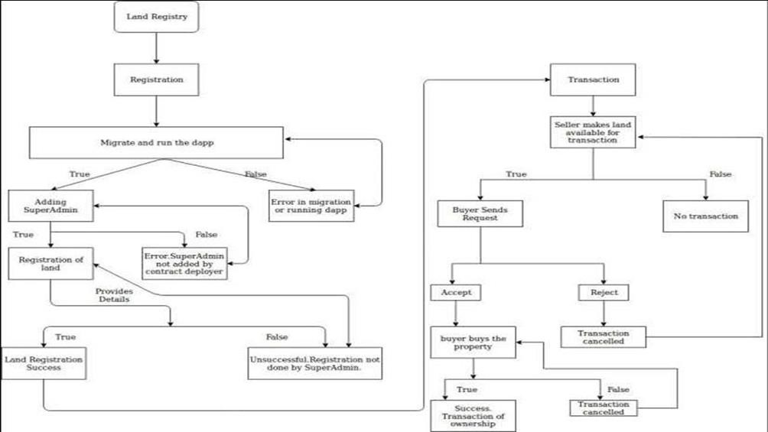

Figure-: 3 Data flow across various Land Registration Module

Problem Definition

Overview

Land ownership and property transactions form the foundation of economic stability and governance in any country. However, the existing land registry systems in India continue to rely heavily on manual and centralized processes. These systems often suffer from inefficiency, corruption, and lack of transparency, which result in ownership disputes and fraudulent transfers. To address these issues, this project proposes a blockchain-based Land Registry System that ensures secure, immutable, and transparent record-keeping. The system leverages smart contracts and decentralized ledger technology to automate ownership verification and reduce reliance on intermediaries.

Problem Statement

The current land registration process in India is inefficient, time-consuming, and prone to manipulation due to its centralized structure and paper-based documentation. There is a high risk of fraudulent activities, unauthorized ownership transfers, and data loss. Existing digital platforms, such as DLRMP, still rely on centralized databases that are susceptible to hacking or corruption. Hence, there is a need for a decentralized blockchain-based framework that can store land records securely, provide real-time access to all stakeholders, and automate verification and transfer processes through smart contracts.

Challenges Identified

    - Data Security and Integrity: Ensuring the immutability and protection of land records from tampering or unauthorized access.
    - Centralization Issues: Overcoming the single point of failure in current systems by implementing a decentralized ledger.
    - Integration with Government Databases: Difficulty in integrating blockchain with existing record management and verification systems.

    - Lack of Awareness and Technical Expertise: Limited understanding of blockchain among government officials and citizens.
    - Legal and Regulatory Constraints: Absence of clear policies for blockchain adoption in public record management.

Why This Problem is Important

Land disputes are among the most common and long-lasting legal issues in India, often caused by poor documentation and lack of transparency. A secure and efficient land registry system can significantly reduce fraudulent property transfers and improve citizen trust in public institutions. Implementing blockchain in this domain supports good governance, promotes digital transformation, and aligns with the Government of India’s vision for Digital India. Moreover, by eliminating intermediaries and automating transactions, blockchain reduces corruption and administrative burden, making land registration more efficient and reliable.

Problem Definition in Context of Land Registry using Blockchain

In the context of a blockchain-based system, the problem is defined as:

“To design and implement a decentralized Land Registry System that leverages blockchain
and smart contract technologies to provide a secure, transparent, and tamper-proof
mechanism for property registration, ownership verification, and transfer.”

This problem focuses on replacing traditional centralized databases with a blockchain network that ensures data integrity, immutability, and traceability. The solution aims to make land ownership information publicly verifiable while maintaining privacy and role-based access for government officials, thereby improving efficiency, security, and public trust in the land management process.

Proposed System

Introduction

The proposed system introduces a Blockchain-based Land Registry Platform designed to replace the traditional centralized and paper-based registration process. It aims to make land record management secure, transparent, and tamper-proof using blockchain and smart contract technologies. The system provides a decentralized framework where all property transactions and ownership details are recorded as blocks in a distributed ledger. This ensures immutability (data cannot be altered), transparency (all stakeholders can verify transactions), and accountability (every change is traceable).
The use of smart contracts automates key operations such as property transfer, document verification, and payment authorization, minimizing human error and eliminating the need for intermediaries. The system benefits citizens, registrars, and government officials by providing real-time access to verified land records through a user-friendly web portal.

System Architecture

The architecture of the proposed system is based on a multi-layered blockchain framework
consisting of the following main components:

User Interface Layer:
      - Provides a web-based portal for buyers, sellers, and government officials.
      - Enables user registration, property upload, document verification, and transaction monitoring.

Application Layer:
      - Handles business logic and API communication between the web interface and blockchain network.
      - Integrates with external modules such as Google Maps API for geo-tagging of property boundaries.

Blockchain Layer:
      - Acts as the core of the system where each property transaction is stored as a block.
      - Ensures immutability, consensus validation, and transparent record maintenance using Ethereum or Hyperledger.

Smart Contract Layer:

      - Automates ownership transfer, verification, and payment release based on predefined conditions.
      - Reduces manual intervention and enforces trust through code execution.

Data Storage Layer:
      - Uses IPFS (InterPlanetary File System) for storing land documents and images securely.
      - Off-chain databases (like PostgreSQL) store user credentials and metadata linked to blockchain transactions.
This layered architecture ensures high reliability, scalability, and security while allowing seamless integration between users and the blockchain network.

Framework of the Proposed System

The proposed framework consists of three key entities — User (Buyer/Seller), Land Inspector, and Government Authority.

User (Buyer/Seller):
Registers on the platform, uploads documents, and initiates buy/sell requests. Each transaction is verified and recorded on the blockchain.

Land Inspector:
Verifies property documents, checks transaction validity, and triggers smart contracts to finalize ownership transfer.

Government Authority:
Oversees system activities, verifies compliance, and ensures that blockchain transactions align with legal protocols.
The framework operates as follows:

    - All registered users are assigned a unique blockchain address.
    - Property data and related documents are stored in IPFS, with their hash values recorded on the blockchain.
    - Smart contracts validate ownership and initiate payment transfer once verification is complete.
    - Ownership changes are updated automatically on the blockchain ledger, visible to all authorized users.

This framework ensures decentralized control, automated verification, and immutable transaction records — addressing the inefficiencies of the existing centralized system.

Algorithm and Process Design

The system’s process flow is governed by smart contracts that define a series of automated
actions. The key algorithms and process steps are as follows:

Algorithm: Smart Contract Execution for Land Transfer

    - Input: Buyer ID, Seller ID, Property ID, Verification Status.
    - If (Verification == True):
      - Execute smart contract.
      - Transfer property ownership from seller to buyer.
      - Update transaction details on blockchain.
      - Release payment to seller.

Else:
      - Terminate transaction.
      - Notify both parties of incomplete verification.

Process Design:

- User Registration:
Users (buyers/sellers) register by submitting personal and ID details. The system stores data as a cryptographic hash on the blockchain.

Property Upload:
Sellers upload property details and ownership documents. The system stores document hashes in IPFS, ensuring authenticity.

Access Request:
Buyers send property access requests, which sellers approve or reject. All requests are recorded on the blockchain.

Verification and Approval:
Land Inspector verifies property details and triggers the smart contract once authenticity is confirmed.

Ownership Transfer:
The smart contract automatically transfers ownership, updates the blockchain record, and sends confirmation to both parties.

Transaction Record:
Every transaction, approval, and update is permanently stored in the blockchain, providing full traceability and transparency.

System Requirement

Hardware Requirements:
- RAM: 4 GB or more
- Storage: At least 500 MB free disk space
- Internet Connection: Required for accessing APIs and blockchain network

Software Requirements :

- Programming Language: Python 3.x
- Blockchain Platform: Ethereum / Hyperledger
- Smart Contracts: Solidity (if using Ethereum)
- ​
- Web Stack: HTML, CSS, JavaScript, React / Angular
- Backend: Node.js / Python (Flask/Django)
- Database: IPFS (for document storage), PostgreSQL (for off-chain data)
- Libraries/Packages: requests, pandas
- Code Editor/IDE: Jupyter Notebook / VS Code
- Operating System: Windows / Linux / Mac

3 System Design and Analysis

3.1 Requirement Analysis

3.1.1 Functional Requirements
These requirements define the core actions the system must perform to satisfy the needs of land buyers, sellers, and government authorities.
- User Registration & Authentication: Secure sign-up/login for all stakeholders (Citizens, Land Inspectors, Administrators) using digital wallets (e.g., MetaMask).
- Property Listing: Ability for owners to upload land details, including GPS coordinates, parcel dimensions, and historical scanned deeds.
- Smart Contract Execution: Automated transfer of ownership once conditions (payment, legal clearance) are met.
- Verification Workflow: A dedicated portal for Land Inspectors to review, approve, or reject new property listings and transfer requests.
- Immutable Audit Trail: A publicly accessible ledger to view the historical ownership chain of any land parcel.

Req. ID | Feature | Description | Priority
FR-01 | User Authentication | Users must be able to log in using a digital wallet (e.g., MetaMask) to prove identity via private keys. | High
FR-02 | Land Registration | Landowners must be able to upload land details (size, location, coordinates) and digital deeds. | High
FR-03 | Verification Workflow | Government officials must have a dashboard to review, verify, and digitally sign off on land claims. | High
FR-04 | Smart Contract Transfer | The system must automatically update ownership records once a buyer's payment is confirmed. | High
FR-05 | Search & History | Any user should be able to search a land ID to see its full, immutable transaction history. | Medium

3.1.2 Non-Functional Requirements
These specify the quality attributes and constraints of the system.
- Security: Multi-layer encryption for sensitive data and consensus-based validation for all transactions.
- Immutability: Once a land record is confirmed, it must be impossible for any party (including admins) to delete or modify it.
- Availability: The decentralized nature of the blockchain should ensure $99.9\%$ uptime, as the system does not rely on a single server.
- Scalability: The architecture must handle a growing number of land transactions without significant latency.
- Transparency: All transaction logs must be auditable by any stakeholder while maintaining user privacy through cryptographic addresses.

Category | Requirement | Description
Security | Data Integrity | Use of SHA-256 hashing to ensure that once a block is added, it cannot be altered without detection.
Availability | System Uptime | The decentralized node network should ensure 24/7 availability with no single point of failure.
Transparency | Public Audit | All ownership transfers must be publicly verifiable on the ledger while keeping user IDs pseudonymous.
Performance | Transaction Speed | The system should process and validate a land transaction within 15–30 seconds (depending on the network).
Usability | UI Responsiveness | The web interface must be intuitive for users with minimal technical knowledge of blockchain.

3.1.3 Hardware Requirements
The system requires specific hardware for nodes and client-side interaction:
- Blockchain Nodes: Quad-core CPU, 16GB RAM, and 500GB SSD (for storing the distributed ledger).
- Client Devices: Standard PCs or mobile devices with internet connectivity and modern browsers supporting Web3 extensions.
- Storage (IPFS): Distributed storage servers for hosting large image files and PDF documents that are too bulky for on-chain storage.

A. Server/Node Requirements

Component | Minimum Specification | Recommended Specification
Processor | Dual-core CPU (2.0 GHz) | Quad-core CPU (3.0 GHz+)
RAM | 8 GB | 16 GB
Storage | 256 GB SSD | 512 GB SSD (for growing ledger)
Network | 10 Mbps stable connection | 100 Mbps+ fiber connection

B. Client/End-User Requirements

Component | Minimum Specification
Device | Smartphone, Tablet, or Laptop
Browser | Chrome, Brave, or Firefox (with Web3 extension support)
Storage | Minimal (Web-based application)
Input | GPS-enabled device (for on-site land verification)

3.2 System Architecture
The BlockPlot system follows a Three-Tier Architecture to ensure modularity and ease of maintenance.

3.2.1 Client Tier (Frontend)
This is the user-facing layer.
- Technologies: React.js or Flutter for a responsive UI.
- Role: Handles user interaction, form submissions for land data, and integration with digital wallets like MetaMask for signing transactions.

3.2.2 Logic Tier (Backend)
The intermediary layer that connects the UI to the blockchain.
- Technologies: Node.js, Web3.js, or Ethers.js.
- Role: Acts as the bridge, relaying calls from the frontend to the smart contracts and querying the blockchain for data retrieval.

3.2.3 Data Tier (Models and Configuration)
The storage layer where data persistence occurs.
- On-Chain (Blockchain): Stores ownership status, transaction hashes, and smart contract state.
- Off-Chain (IPFS/NoSQL): Stores heavy files like land photos and deeds (on IPFS) and temporary session data or user profiles (on MongoDB).

Overview of System Design

The system design phase focuses on translating the proposed concept into a practical and functional architecture. It defines the overall structure of the Land Registry System using Blockchain, specifying its key components, data flow, and interactions between modules. The design ensures that the system provides security, transparency, immutability, and scalability in handling land ownership data.
The system consists of multiple integrated layers — the frontend (user interface) for interaction, the backend for data processing and communication, and the blockchain layer for transaction validation and storage. Each transaction (such as property registration, verification, and ownership transfer) is validated through smart contracts, ensuring that only legitimate and authorized operations occur.

Chapter 4

Methodology And Implementation

4.1 Development Methodology
The project followed the Agile Methodology, allowing for iterative development and continuous feedback. The methodology adopted in the system design follows a modular and iterative approach, focusing on security, decentralization, and automation.

4.1.1 Sprint Structure
Development was divided into two-week sprints:
- Sprint 1: Requirement finalization and Environment setup (Node.js, Hardhat).
- Sprint 2: Smart Contract development (Solidity) and local testing.
- Sprint 3: Backend API development and IPFS integration.
- Sprint 4: Frontend UI development and Wallet integration.
- Sprint 5: Security auditing, bug fixing, and deployment.

4.1.2 Testing Approach
- Unit Testing: Individual functions in Smart Contracts were tested using the Waffle framework.
- Integration Testing: Verified that the Frontend correctly communicates with the Blockchain via the Backend.
- Security Testing: Focused on gas optimization and preventing common vulnerabilities like Reentrancy.
The key factors taken into consideration:

Requirement Analysis:
Identification of functional and non-functional requirements, user roles, and security needs for data management.

System Architecture Design:
Designing a multi-layered blockchain-based structure with frontend, backend, and smart contract integration.

Smart Contract Development:
Writing Solidity-based smart contracts that handle ownership transfers, verification, and payment automation.

Integration of IPFS and Database:
Storing property-related documents in IPFS (for immutability) and metadata in a relational database like PostgreSQL.

Testing and Deployment:
Using blockchain test environments (like Ganache/Truffle) to simulate real-world scenarios before deployment to the main network.
This methodology ensures that the final system is secure, reliable, and fully decentralized, providing transparent land registration and verification.

4.2 Technical Implementation Details

4.2.1 REST API Endpoints
The backend provides endpoints for off-chain data management.
Method | Endpoint | Description
POST | /api/upload | Uploads deed to IPFS and returns the CID (Hash).
GET | /api/land/:id | Fetches land metadata from the NoSQL database.
POST | /api/verify | Inspector submits verification status.

4.2.2 Socket.IO Events
Used for real-time updates in the messaging and notification modules.
- connection: Triggers when a user logs in.
- private_message: Emits encrypted text between buyer and seller.
- notif_transfer: Alerts the user when a land transfer is finalized.

4.2.3 Middleware Stack and Security Hardening
- Helmet.js: Secures Express apps by setting various HTTP headers.
- Rate Limiting: Prevents Brute Force/DDoS attacks on the API.
- JWT (JSON Web Tokens): Used for session management after the initial wallet signature.

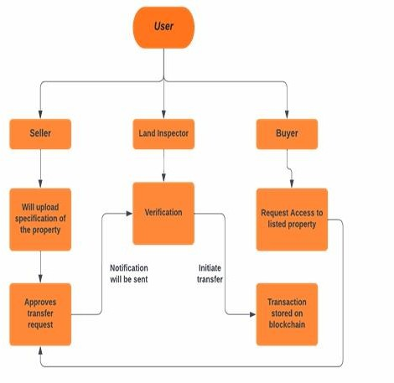.

Figure-:4 Methodology Land Registration Verification Flowchart

4.3 Deployment Design

The deployment phase involves setting up the software environment, blockchain network, and web interface to make the system operational.

Frontend Deployment:
The user interface, developed using HTML, CSS, and JavaScript (React or Angular), is hosted on a cloud-based web server such as AWS, Heroku, or Netlify.

Backend Deployment:
The backend services (Node.js or Python Flask/Django) handle smart contract interactions and API communication. These services are hosted on a secure cloud platform ensuring high availability.

Blockchain Network Deployment:
The blockchain is implemented on the Ethereum platform, using Ganache for testing and Remix IDE for contract execution. Once verified, contracts are deployed to the Ethereum mainnet or a private blockchain network.

Database and IPFS Deployment:
Property documents are stored in IPFS, while off-chain data such as user profiles and transaction metadata are managed in a PostgreSQL database linked to the blockchain through APIs.

Security and Monitoring:
Continuous Integration/Continuous Deployment (CI/CD) pipelines are established for version control, and network monitoring tools are used to ensure transparency and detect anomalies.

4.4 Design of Data Flow

The data flow design illustrates how data moves between users, application layers, and the blockchain system.

1. User Registration Phase:
      - User submits personal and ID details through the interface.
      - Data is hashed and stored on the blockchain with user authentication credentials in the database.

2. Property Upload Phase:
      - Seller uploads property details and documents.
      - Document hashes are stored on the blockchain, while files are uploaded to IPFS.

3. Access and Verification Phase:
      - Buyer sends a request to view property details.
      - Seller or inspector verifies and grants access through smart contract approval.

4. Ownership Transfer Phase:
      - After verification, the smart contract executes the transaction.
      - Ownership is transferred to the buyer, and the blockchain ledger is updated.

Notification and Record Phase:
      - Both parties receive confirmation.
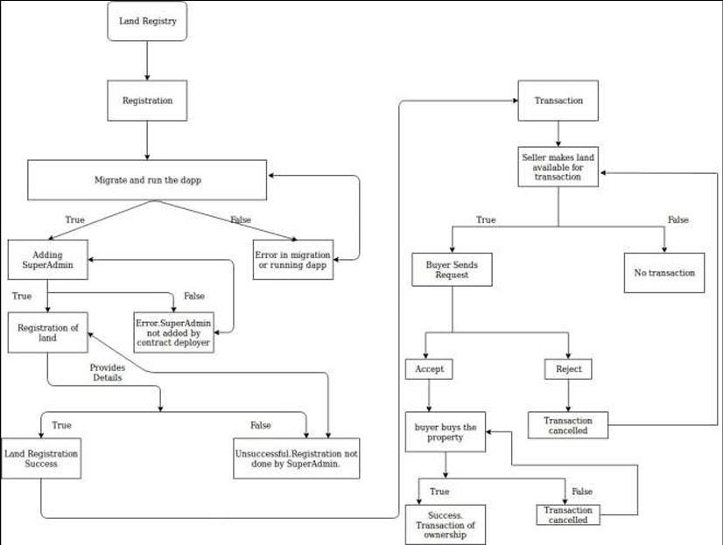
b. Transaction details remain permanently stored on the blockchain, ensuring transparency

Figure-: 5 Design Of Data Flow Flowchart

4.5 Data Flow Diagram (DFD)

Level 0 (Context Level DFD):

- Represents the system as a single entity “Land Registry System.”
- External Entities: User (Buyer/Seller), Land Inspector, and Government Authority.
- Processes: Registration, Verification, Property Transfer.
- Data Stores: Blockchain Ledger, IPFS, and Database.

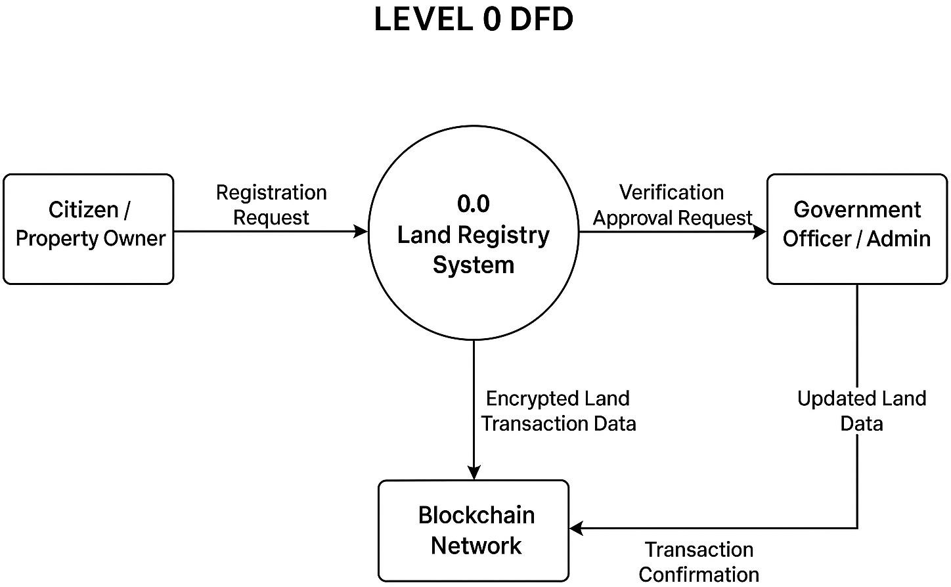

Figure-:6 Data Flow Digram

Flow Summary:
Users interact with the system to upload, verify, and transfer land records. The system communicates with blockchain and databases to validate and record transactions.

Level 1 (Detailed DFD):

    - Process 1: User Registration
      - Input: User details → Output: Verified user hash on blockchain.

Process 2: Property Management
      - Input: Property data and documents → Output: Stored in IPFS, hash on
blockchain.

Process 3: Verification and Approval
      - Input: Request from buyer and inspector verification → Output: Smart
contract approval.

Process 4: Ownership Transfer
      - Input: Verified ownership and payment → Output: Ownership recorded and
updated in blockchain.

Process 5: Record and Notification
      - Input: Finalized transaction → Output: Confirmation sent to all stakeholders.

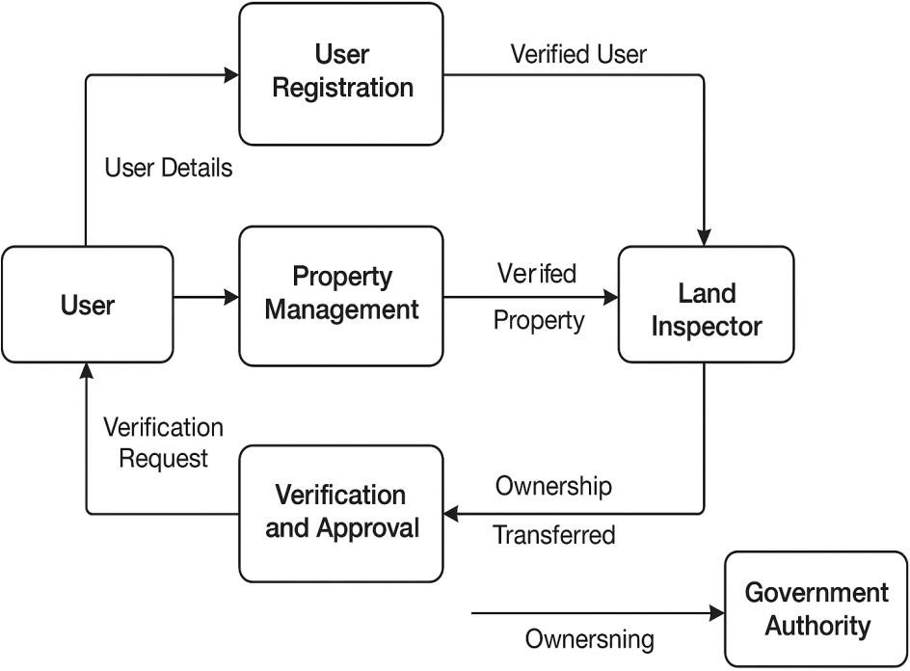

Figure-: 7 Blockchain Record Transactions

Chapter 5

Results And Discussion

5.1 Overview

The outputs of the Land Registry System using Blockchain represent the tangible and digital results generated by the system after executing its core processes — such as registration, verification, and ownership transfer. Each output reflects successful integration between the user interface, backend processing, blockchain ledger, and smart contracts. These outputs confirm that the proposed system performs as intended — offering transparency, automation, and secure record management.

Figure-:9 Successful deployment of contract
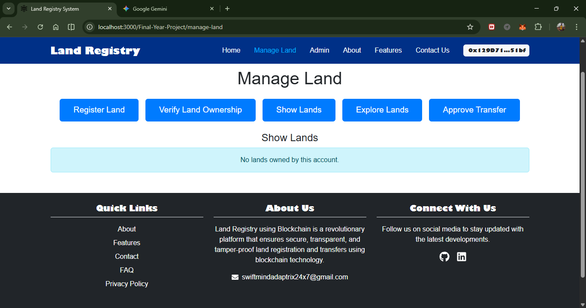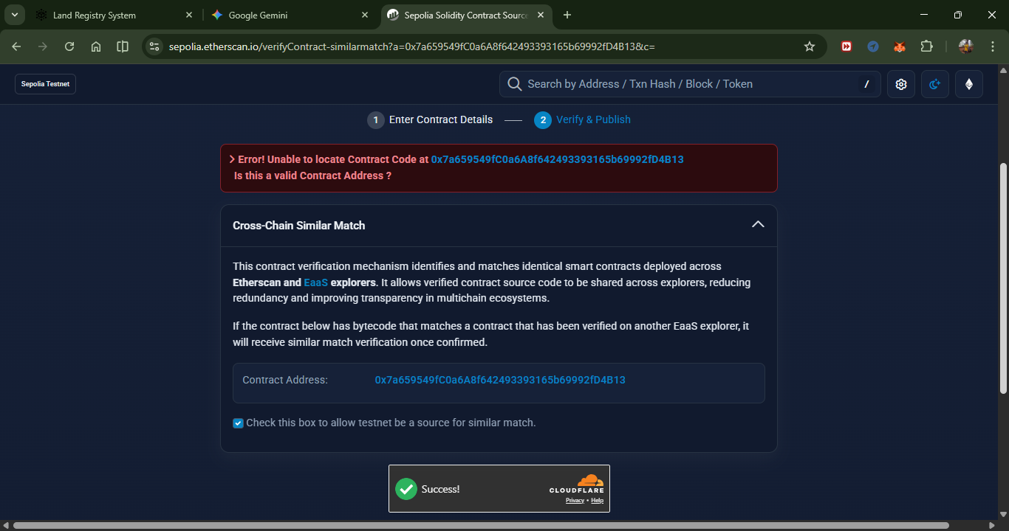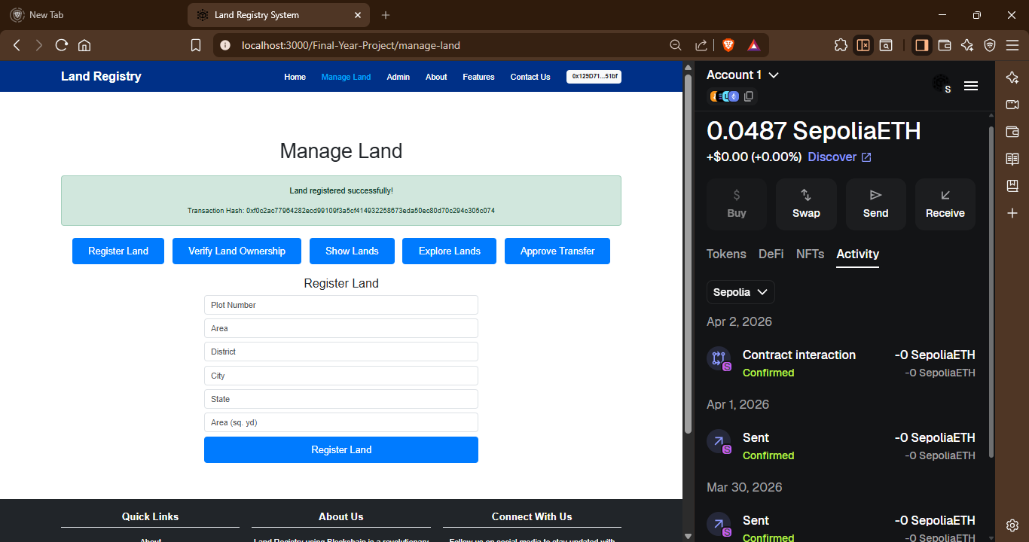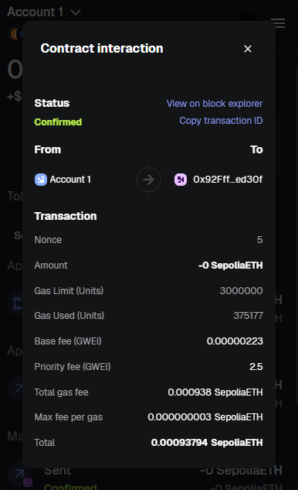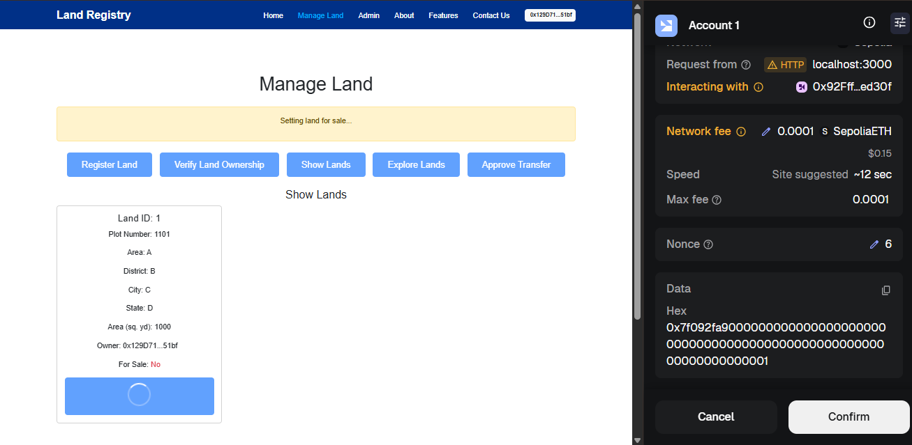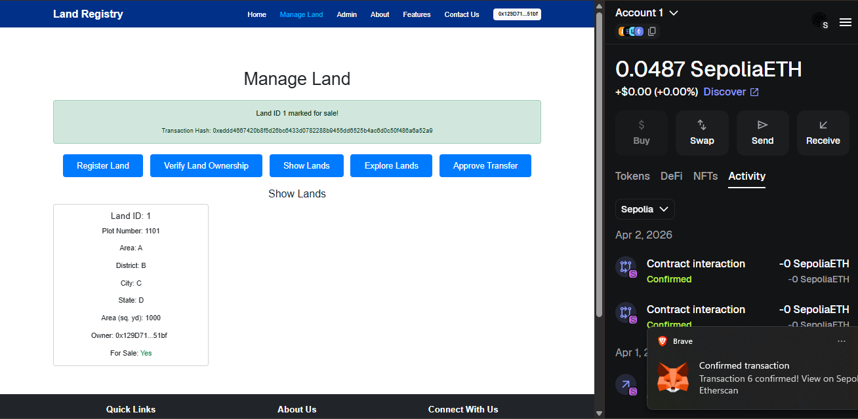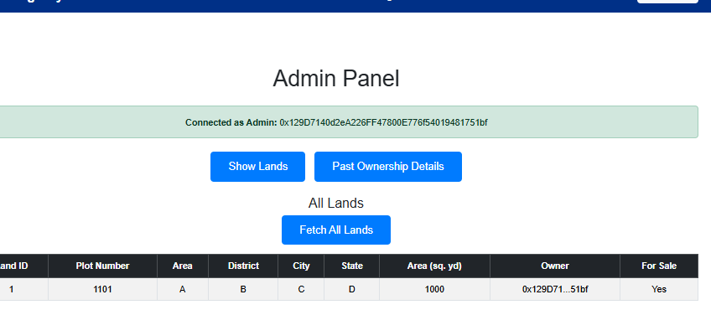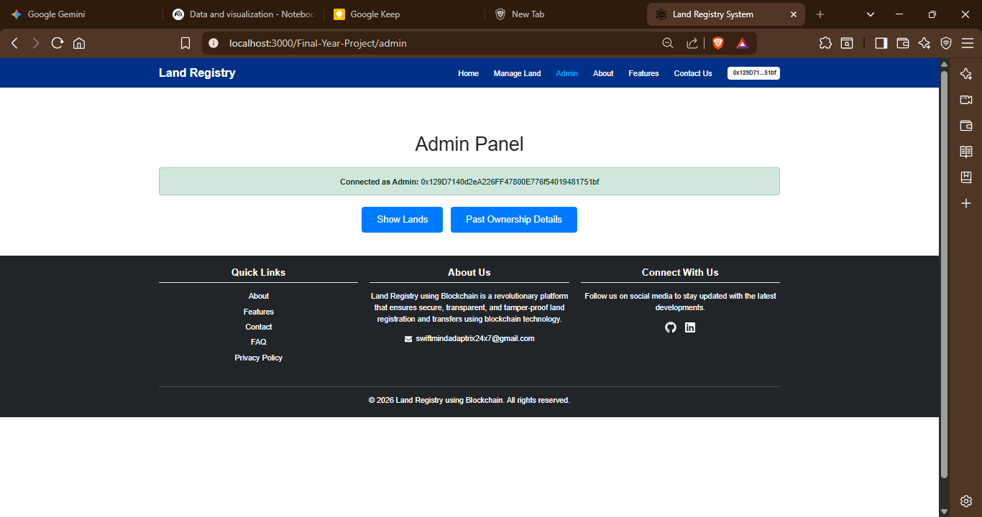

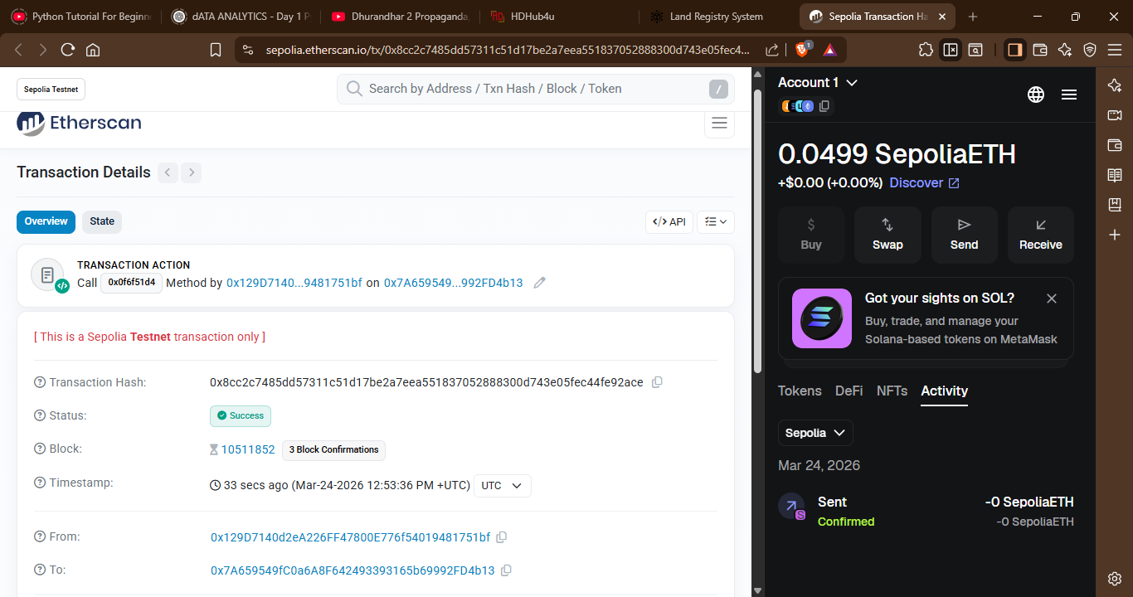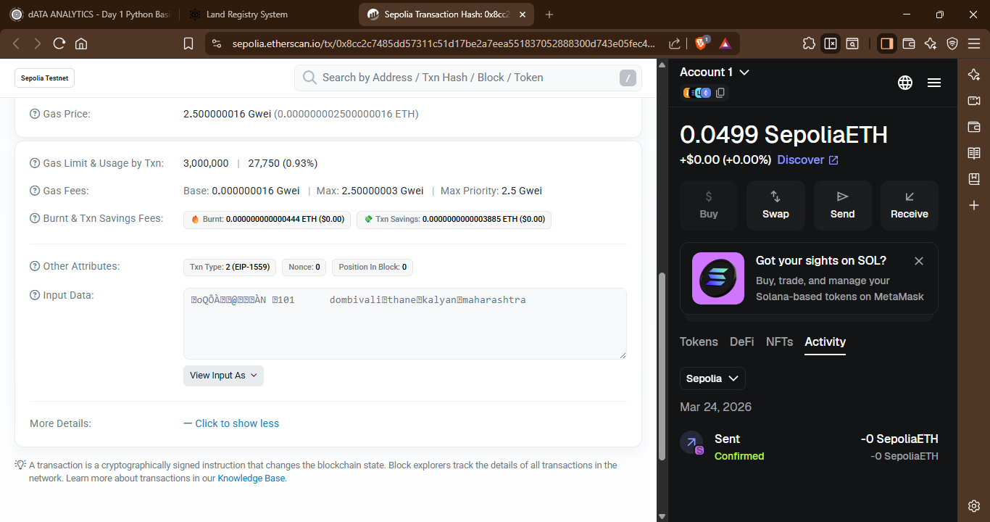

USER SIDE INTERFACE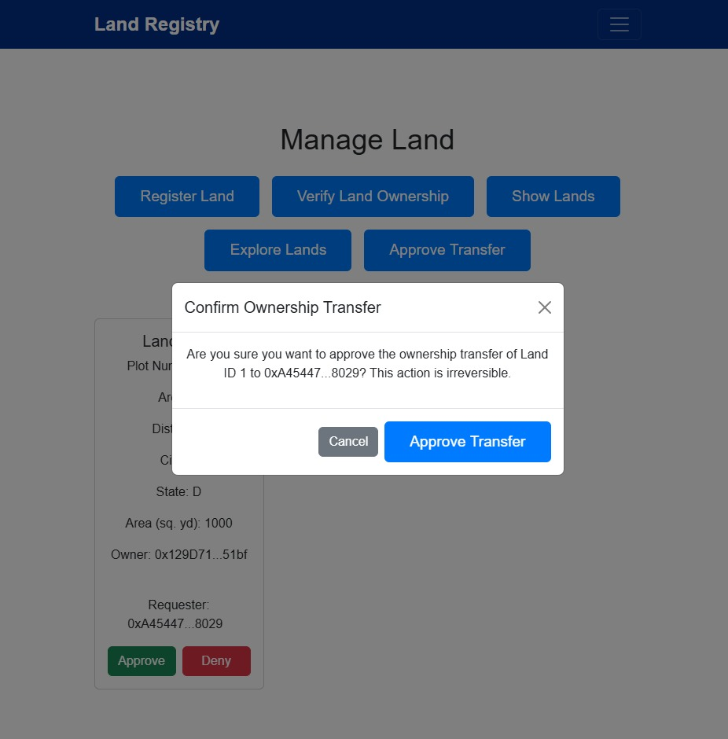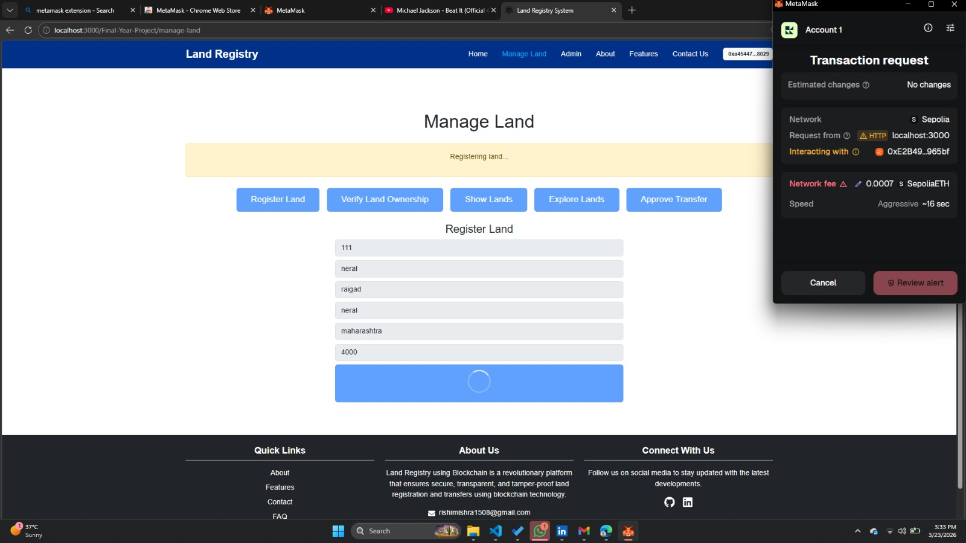

Chapter 6
Conclusion And Future Work

6.1 Conclusion
The proposed Land Registry System using Blockchain successfully addresses the inefficiencies and vulnerabilities of traditional, paper-based, and centralized land
management systems. By leveraging blockchain’s decentralized and immutable nature, the system ensures that all property transactions and ownership records are stored securely and transparently. The integration of smart contracts automates crucial processes like ownership verification, transfer, and payment release, thereby eliminating intermediaries and reducing human error. Additionally, the use of IPFS for document storage enhances data security and accessibility.
This blockchain-driven approach not only improves transparency and efficiency but also strengthens public trust in government systems. The project demonstrates how modern technology can be integrated into governance frameworks to create a tamper-proof, scalable, and efficient land registration system that promotes accountability and digital transformation.

6.2 Impact of the Project
- Technological Impact: Introduces the concept of decentralization in land management, promoting secure, traceable, and transparent digital records through blockchain and smart contracts.
- Social Impact: Builds trust among citizens by reducing corruption, fraud, and manipulation in property transactions. People can easily verify land ownership records without relying on intermediaries.
- Administrative Impact: Reduces workload and paperwork for government officials by automating verification and transfer processes, allowing faster service delivery and better governance.
- Economic Impact: Minimizes costs associated with land disputes, legal verification, and fraudulent transactions, contributing to improved economic efficiency.
- Environmental Impact: Supports a paperless digital ecosystem, reducing physical record maintenance and contributing to environmental sustainability.
6.3 Benefits of the Proposed System

Enhanced Security:
Blockchain’s immutable ledger ensures that once data is stored, it cannot be altered
or deleted, eliminating the risk of fraud and data tampering.

Transparency and Trust:
Every transaction is recorded on a distributed ledger visible to authorized users, ensuring complete transparency in land ownership and transfer.

Efficiency and Speed:
Smart contracts automate the entire process of verification and ownership transfer, reducing time delays and manual intervention.

Cost Reduction:
Eliminates the need for intermediaries, brokers, and excessive paperwork, reducing operational and administrative costs.

Scalability and Accessibility:
The system can be scaled to manage millions of records and accessed from anywhere through a secure web interface, ensuring inclusivity for citizens across regions.

Real-Time Verification:
Property details, ownership status, and transaction history can be verified instantly, minimizing disputes and enhancing reliability.

6.2 Future Work
While BlockPlot establishes a solid foundation for decentralized land registration, there are several areas for future development:
- Integration with IoT and GIS: Future iterations could incorporate Internet of Things (IoT) sensors and advanced Geographic Information Systems (GIS) for real-time land boundary monitoring and automated surveying updates.
- AI-Driven Dispute Resolution: Implementing Machine Learning algorithms to analyze historical records and predict potential legal conflicts before they arise, further streamlining the verification process.
- Cross-Chain Interoperability: Enabling the system to communicate with other blockchain networks (e.g., for cross-border investments or mortgage collateralization with DeFi protocols).
- Legal & Regulatory Integration: Collaborating with government bodies to establish a legal framework where the blockchain record is recognized as the primary "Source of Truth" in a court of law.
- Zero-Knowledge Proofs (ZKP): Enhancing privacy features to allow for the verification of a transaction's validity (e.g., "Does the seller own this land?") without revealing sensitive personal details or the exact sale price to the public.

References
- Nakamoto, S. (2008). Bitcoin: A Peer-to-Peer Electronic Cash System. Retrieved from https://bitcoin.org/bitcoin.pdf
- Crosby, M., Pattanayak, P., Verma, S., & Kalyanaraman, V. (2016). Blockchain Technology: Beyond Bitcoin. Applied Innovation Review, Issue 2, pp. 6–10.
- Zheng, Z., Xie, S., Dai, H., Chen, X., & Wang, H. (2017). An Overview of Blockchain Technology: Architecture, Consensus, and Future Trends. IEEE 6th International Congress on Big Data.
- Ethereum Foundation. (2024). Ethereum Whitepaper – A Next-Generation Smart Contract and Decentralized Application Platform. Available at https://ethereum.org/en/whitepaper/
- IPFS Documentation. (2024). InterPlanetary File System – Distributed Web Storage.
Retrieved from https://docs.ipfs.tech/
- Government of India. (2023). Digital Land Records Modernization Programme (DLRMP) – Guidelines. Ministry of Rural Development.
- Ministry of Rural Development, Government of India, “Digital Land Records Modernization Programme (DLRMP) – Guidelines,” 2023.

